Lab: DOM XSS in document.write sink using source location.search
Prepared by: Nihar Mane

INDEX
Report Metadata ……………………………………………………………………….……….2
Executive Summary…………………………………………………………………………….2
Scope …………………………………………………………………………………………….2
Methodology……………………………………………………………………………………..2
Step-by-step Procedure………………………………………………………………………...2
Impact Assessment……………………………………………………………………………..4
Remediation……………………………………………………………………………………..4
Conclusion……………………………………………………………………………………….5
References……………………………………………………………………………………….5

Report Metadata
Lab: DOM XSS in document.write sink using source location.search — PortSwigger Web Security Academy (Apprentice). Target: blog search feature (/?search=). Tools: Burp Suite Community Edition, browser DevTools

Executive Summary
This lab demonstrates a DOM-based XSS vulnerability where the blog’s search page writes the search term into the page via document.write() inside an <img> tag, without encoding it. Submitting the payload "><svg onload=alert(1)> breaks out of the img tag’s src attribute and injects a new element whose onload handler executes arbitrary JavaScript.

Scope
In scope: the search parameter on the blog search page of the assigned PortSwigger lab instance.
Out scope: all other endpoints and any production system.

Methodology
Submit a test string in the search box and use DevTools to locate where it lands in the DOM, then craft a payload that escapes that context and triggers script execution.

Step-by-step Procedure

Step 1: We enter a random alphanumeric string in the search box and then hit search.
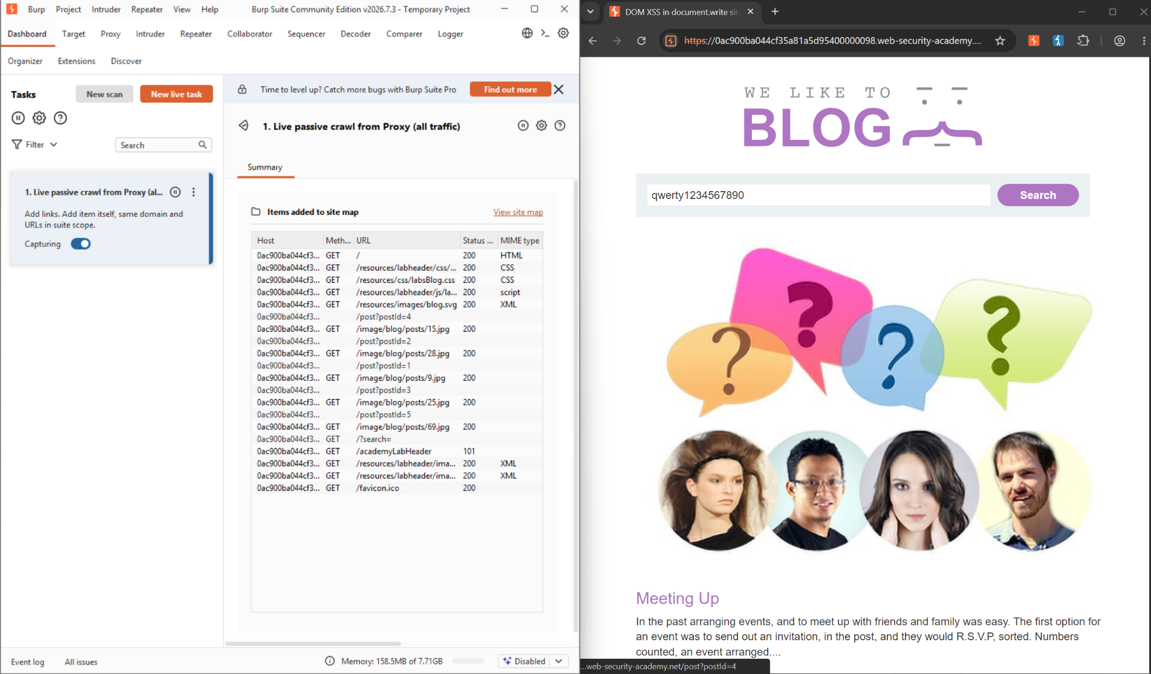

Step 2: We right Click on the search box to inspect it. We should find the alpha numeric string we entered.
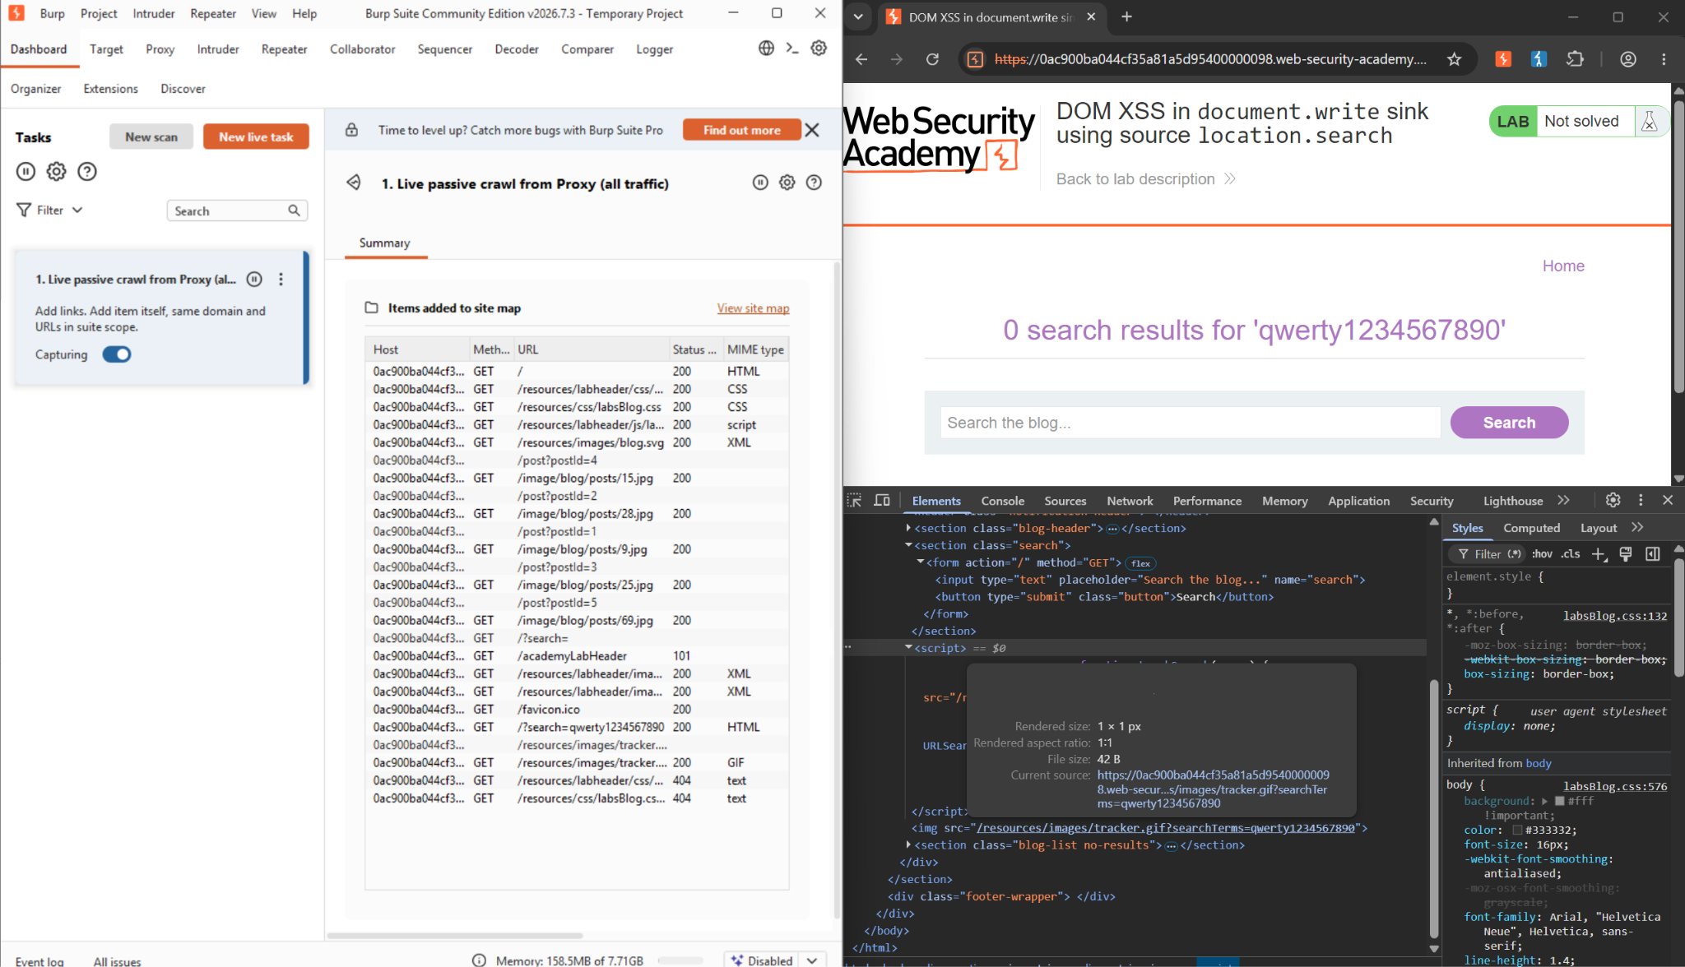

Step 3: Now as we entered "><svg onload=alert(1)> an alert popped up.
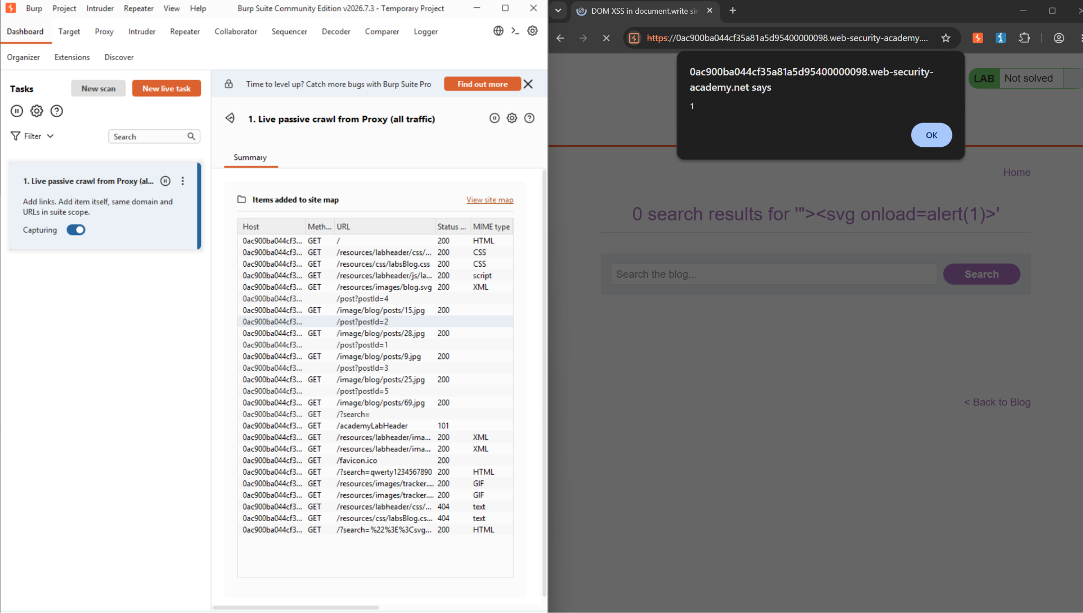

Impact Assessment
• Client-side, purely DOM-based: the payload never reaches the server, so it can evade server-side filters and logging.
• Full script execution: an attacker can hijack the victim’s session or perform actions as them once the payload runs.
• Easy delivery: the attack only requires getting a victim to click a crafted search URL.

Remediation
• Avoid document.write() and other unsafe sinks; use safe DOM APIs like textContent or setAttribute instead.
• If dynamic HTML is unavoidable, HTML-encode any data taken from the URL or other attacker-controllable sources before writing it.
• Apply a Content Security Policy to limit the impact of any script that does execute.

Conclusion
This lab showed that even a purely client-side data flow, from the URL into document.write(), is enough to achieve full script execution, without the server ever seeing the payload. As with the earlier XSS labs, the fix is to never let attacker-controlled data reach an unsafe sink unescaped.

References
- https://portswigger.net/web-security/cross-site-scripting/dom-based/lab-document-write-sink

